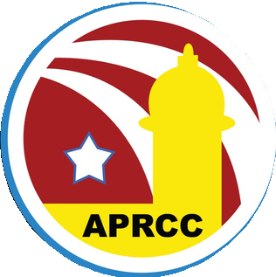
Aurora Puerto Rican Cultural Council

Non-Food Vendor Application 2026
Aurora Puerto Rican Heritage Festival
Sunday July 26, 2026, 12:00 P.M. – 9:00 P.M.
Wilder Park 350 N. River St. Aurora, IL 60506

Application Deadline June 30, 2026

Business Name

Contact Person

Address

City and State Zip

Phone Email

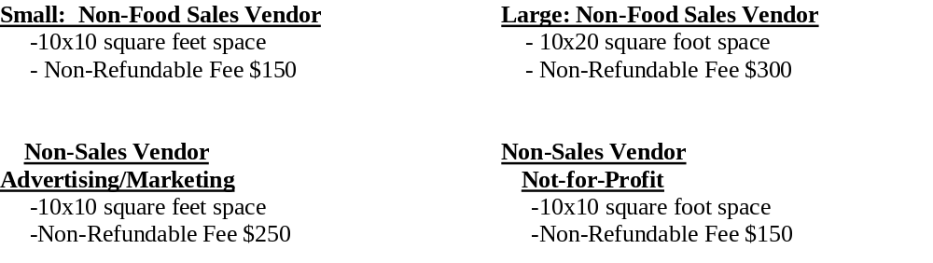

All participating vendors must submit the following to aprccinfo@gmail.com by June 30, 2026.
NO EXCEPTIONS.
Completed and signed 2026 APRCC Vendor Application
Non-refundable vendor fee

Vendor Signature: ______________________________________ Date: _________________

THE VENDOR FEE CAN BE PAID WITH CASH, CHECK OR ZELLE
Make checks payable to APRCC and mail to: APRCC P.O.Box 2802 Aurora, IL 60507
For payments sent via Zelle, please use email: aprccinfo@gmail.com

NON-FOOD VENDOR

RULES & REGULATIONS

Aurora Puerto Rican Heritage Festival: Sunday July 26, 2026
Wilder Park 350 N. River St. Aurora, IL 60506

Set-up begins at 9:00am and all vehicles must be cleared from the festival area by 11:30am. Late arrivals will not be allowed to drive into the festival after 11:30am and will be subject to a fine. Vendors must remain within the festival site until the event ends and early tear downs or driving onto the festival grounds before the end of the festival are not permitted. These rules are strictly enforced with no exceptions. initials

The APRCC will provide the space, but the vendor is responsible for bringing commercial grade extension cords, fencing, chairs, tent/awnings, and weights (sandbags, cinder blocks, etc.) for securing tents. Tent stakes are not permitted; tents must be properly weighted down. We have the right to have the tent removed if it is not properly secured.________initials

APRCC RESERVES EXCLUSIVE RIGHTS TO THE SALE OF WATER, SODA & ALCOHOLIC
BEVERAGES - Vendors are strictly prohibited from selling these items. Violators will be asked to leave premises and may be subject to being banned from future event participation. This will be strictly enforced. _______initials

As a vendor, I have read the APRCC Event Rules and Regulations and will adhere to these rules and communicate any applicable rules to the crew working at my booth and/or to those representing my company.

Vendor Signature Date

